**1.WAP to show the use of Transition and Transform property.**

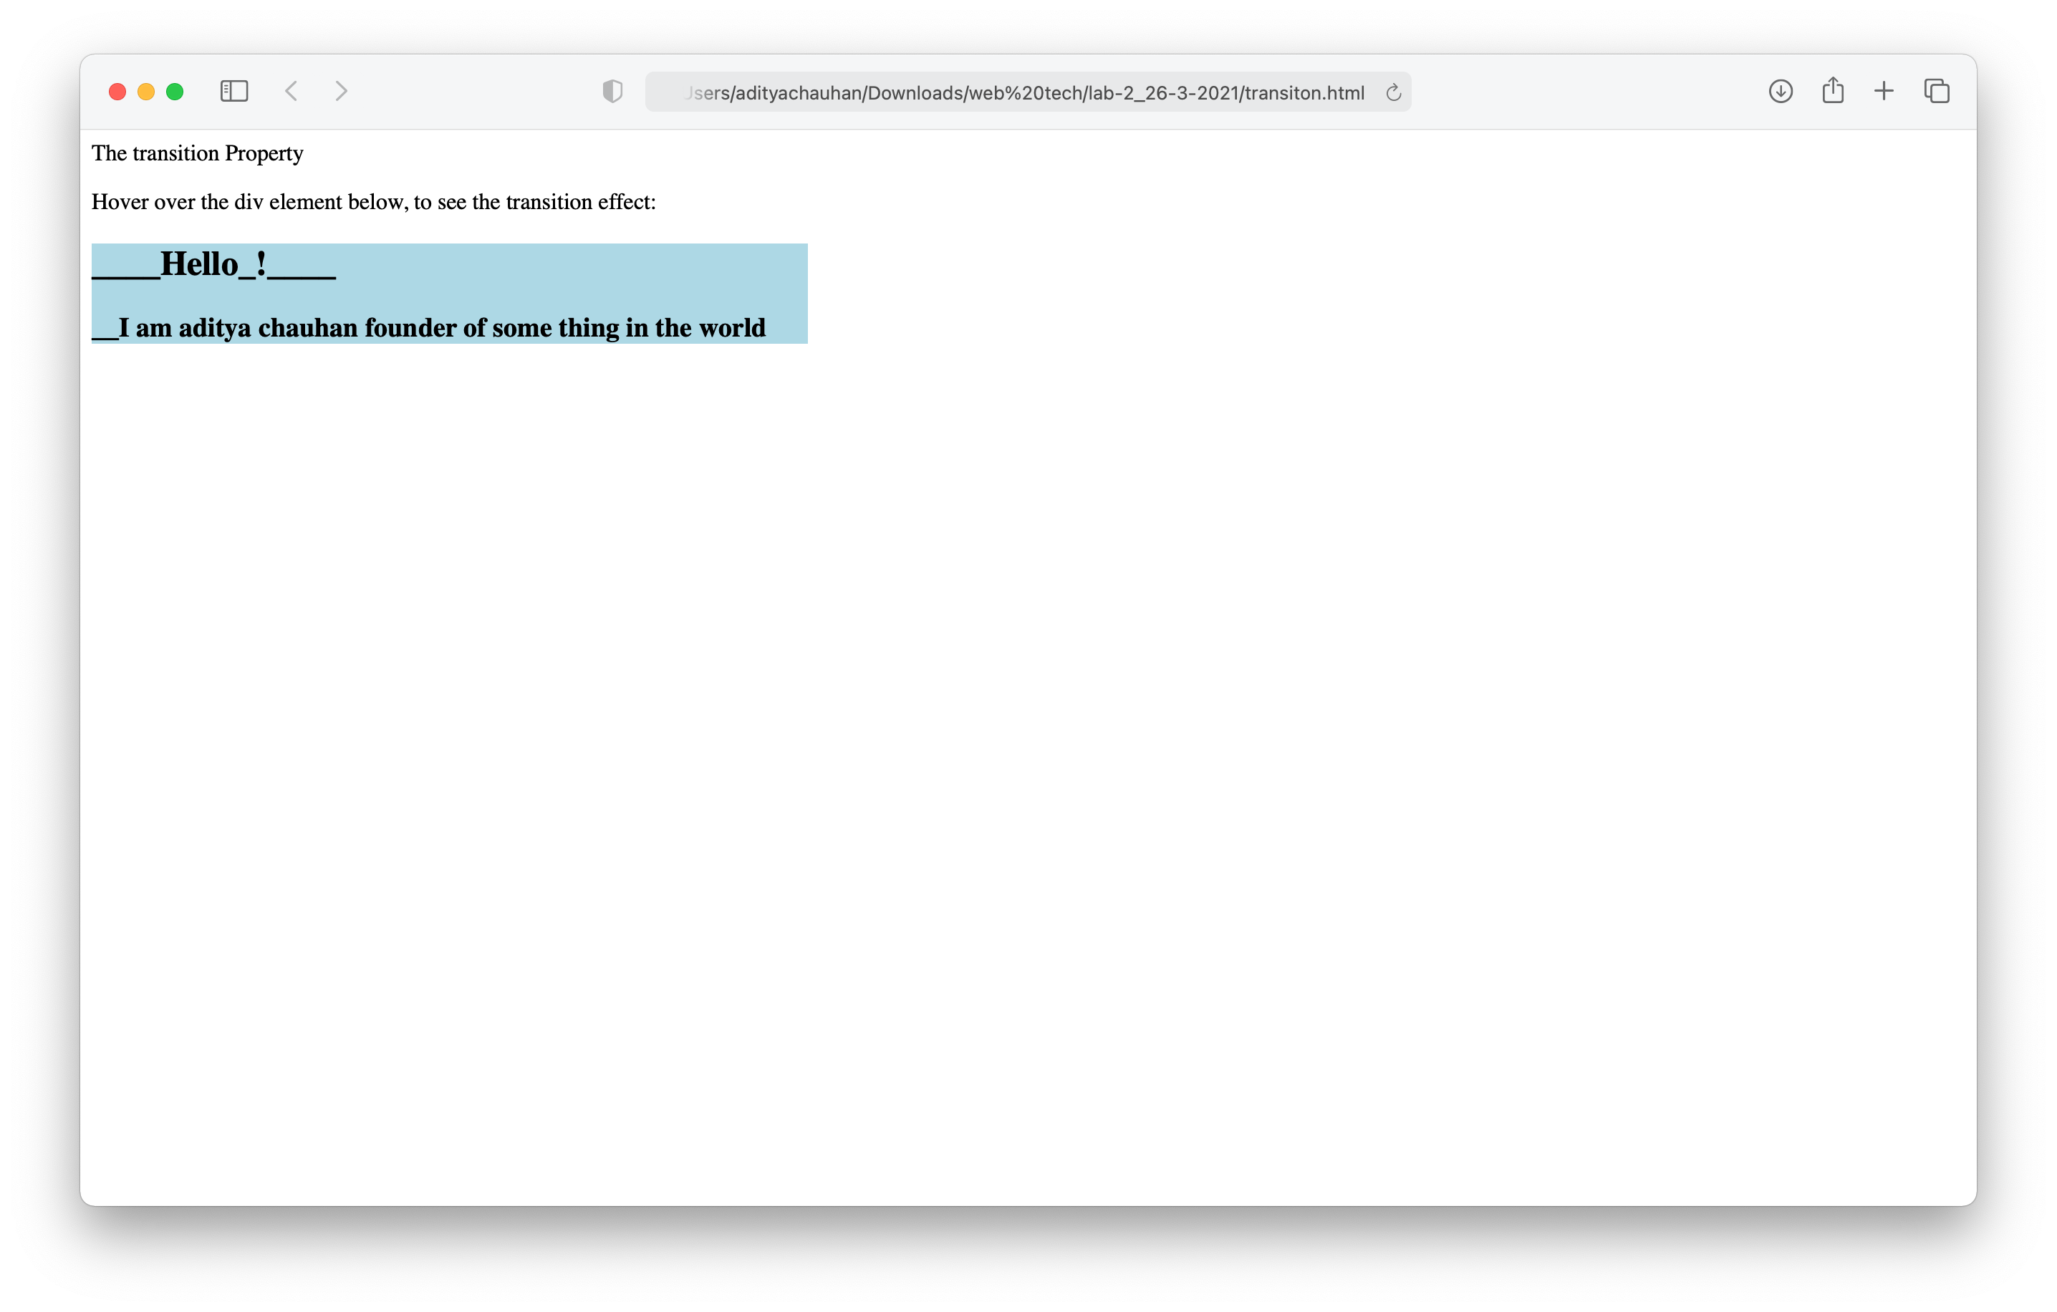

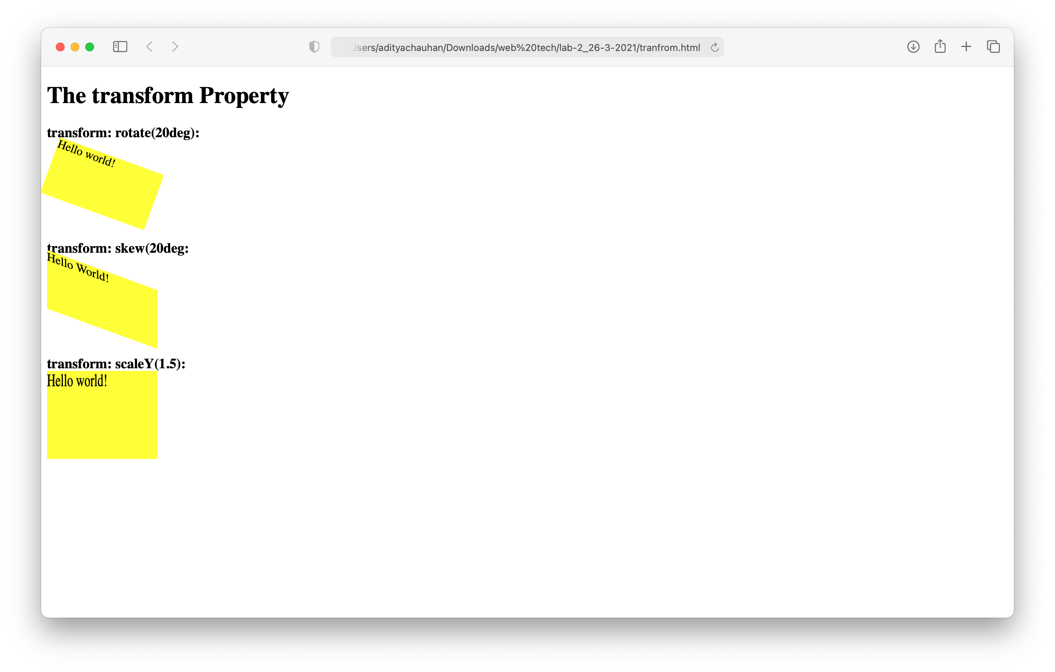

**2.WAP to create different alert Buttons.**

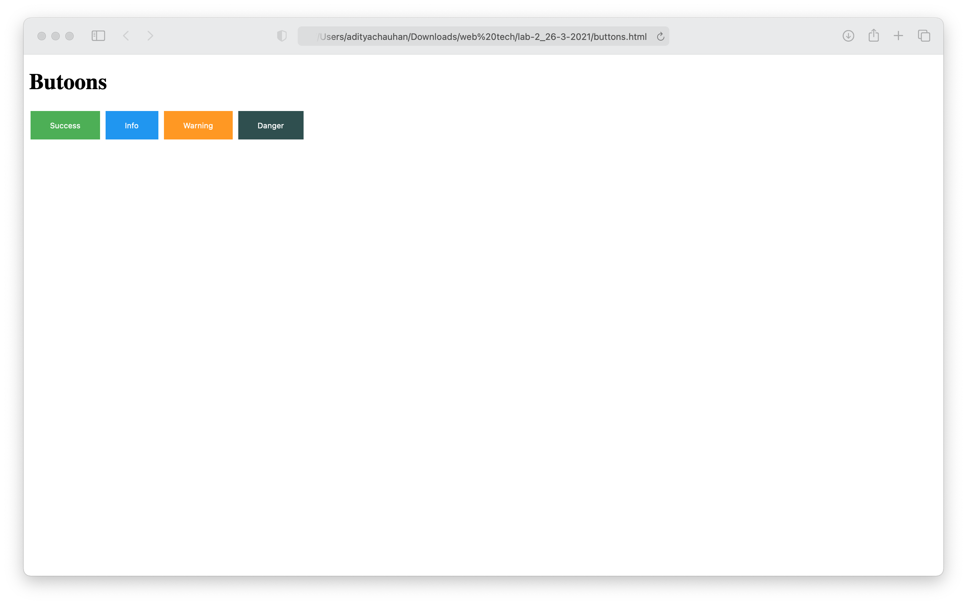

**3. WAP to create From having details of employee.**

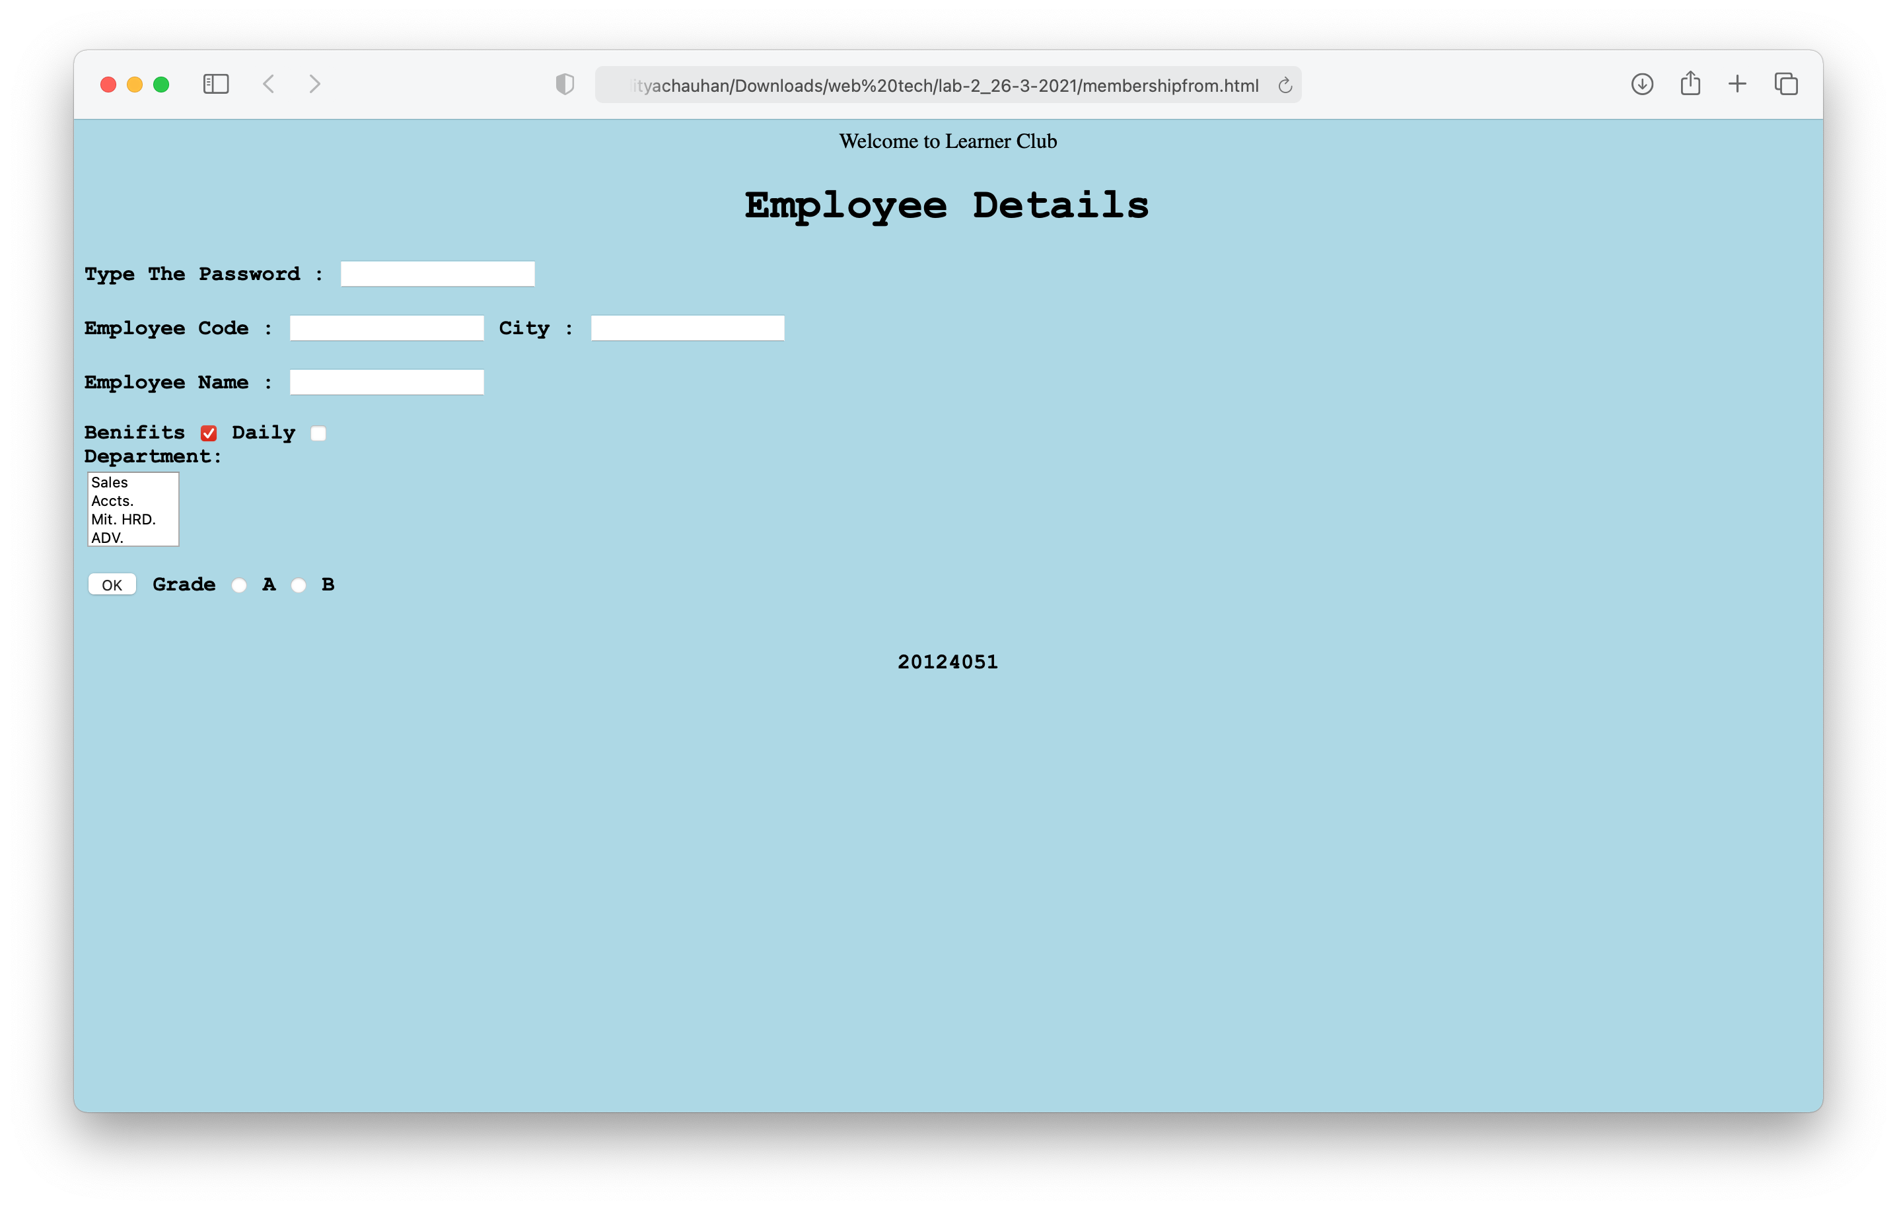

**4. WAP to create a web page which has different functions such as image, background color, hover effect etc.**

